The Decomposition of Gender Inequality in Measurement Error and Agricultural Technology Adoption
Jing Yi¹, Jeisson Prieto², Elisabeth Garner³ and Hale Ann Tufan⁴

Affiliations
¹ Department of Agricultural and Applied Economics, University of Wisconsin, 427 Lorch Street, Madison WI 53706, USA.
² Dyson School of Applied Economics and Management, Cornell University, Ithaca, NY, 14850, USA
³ Center for International Forestry Research (CIFOR), Bogor, Indonesia
⁴ School of Integrative Plant Science, Cornell University, Ithaca, NY, 14850, USA

Abstract
Closing the gender technology gap in agriculture underlies equitable agricultural development interventions. Understanding the nuances of gender disparities in technology adoption by accurately measuring adoption for men and women is pivotal for effective agricultural policy formulation. While a growing body of research has examined gender inequality in technology adoption and measurement errors in self-reported data, this study links these two domains in agriculture. We use an intrahousehold spousal dataset together with DNA fingerprinting results from a survey on improved cassava variety (ICV) adoption in Nigeria. We compare self-reported ICV adoption rates from husbands and wives, with DNA fingerprinting data. We show that wives were systematically underreporting their adoption of ICVs. In contrast, such underreporting is not statistically significant among wives who self-identify as household heads, nor is it evident in husbands’ self-reported data. We explore the importance of unit of analysis and participant selection through empirical validation of the impact of non-classical measurement errors on gender gaps in technology adoptions. Through a decomposition analysis, we further reveal drivers of the gender gaps in ICV adoption, with broader applications to improving methodological approaches and understandings of gender in technology adoption studies more broadly. Our study offers important implications for programs and policies addressing gender inequality, rural development, and food security.
Keywords: Gender inequality, intrahousehold analysis, agricultural technology adoption, cassava, Nigeria

Introduction
Sustainable agricultural development in sub-Saharan Africa relies on agricultural productivity increases, yet the gender productivity gap remains pervasive and persistent (O'Sullivan et al., 2014). The consequences of gender inequalities are far-reaching, affecting not only productivity, but income, poverty levels, and even undernutrition (Amber, Julia, and Anges, 2010). Agricultural research for development is lauded as a highly effective use of public funding to enhance agricultural productivity, albeit with a large amount of heterogeneity in outcomes (Maredia and Anthony, 2010). Improved crop varieties that exhibit favorable characteristics are a key category of agricultural technology, designed to improve the efficiency of agricultural production (Ruzzante et al., 2021). Ample evidence shows, however, that agricultural technology adoption is not gender neutral. To the contrary, gender and social differences shape technology adoption (Doss and Morris, 2000; Peterman et al., 2014). This is important, as enhancing women’s ownership and control over assets, such as improved agricultural technologies, contributes to positive development outcomes at the household and individual levels (Johnson et al., 2016). Understanding the nuances of gender disparities in technology adoption is therefore pivotal for effective agricultural policy formulation to increasing productivity and addressing existing inequalities.
Gender analysis based on sex-disaggregated data from individuals helps researchers and policymakers unpack who benefits from agricultural development interventions (Doss and Kieran, 2013). Improvements in data collection practices have helped to understand women’s asset ownership and decision-making and have also increased the visibility of women and their experiences in agricultural research for development (Doss, 2021). However, most sex-disaggregated datasets remain largely linked to the position of the household head. Headship does not always reflect decision-making rights, nor does it reflect the experiences of women in partnership with male household heads (Peterman et al., 2014; Deere et al., 2010). Further, shifting from a more unitary household model to a collective one focused on experiences of individuals within it may miss out on key dynamics where household members jointly control resources (Doss and Quisumbing, 2020). Interviewing single individuals within households can therefore lead to incorrect conclusions about the household and dynamics therein (Fisher et al., 2010; Twyman et al., 2015).
Interviewing multiple respondents in household surveys provides richer and more nuanced understanding of what happens within these households (Doss, 2021). Recent work on spousal intrahousehold datasets reveals interesting insights on information asymmetries that shape spousal concordance on ownership and decision making in Nepal (Ambler et al., 2021); principal residence valuation in India (Doss et al., 2018); and perceptions of decision making in agriculture (Twyman et al., 2015; Anderson et al., 2017).
Intrahousehold studies on technology adoption offer insight into how household members make decisions on adoption, and what affects these decisions. Recent studies have shown for example how agricultural adoption and productivity differences between female and male plot managers are explained mainly by structural effects (Tufa et al., 2022). Fisher and Kandiwa (2014) reveal significantly different adoption rates of improved maize varieties between women who are single heads of households and women who are wives of male household heads. Further, despite long standing debates over the use of the term household head (Buddlender 2008), there is little exploration of married and co-living women who identify as head of the household. Increasingly nuanced studies reflect the call for more intersectional analyses in agricultural research (Tavenner et al., 2022). For example, status within the household, conferred by gender but also marital status, generation, and education, is linked to adaption of improved sorghum varieties (Smale et al., 2018).
Improved casava (Manihot esculenta) varieties are an important agricultural technology for Nigerian farmers. Cassava is a vital staple crop and its capacity to thrive with minimal external inputs, particularly in the face of environmental stressors such as drought (EL-Sharkawy, 2004), makes it an essential component of food security and resilience strategies (Montagnac et al., 2009). In Nigeria, cassava cultivation is predominantly carried out by smallholder farmers, both men and women (Ahmadu and Idisi, 2014). It occupies a pivotal role in the country’s food economy, ranking as the primary source of carbohydrates after maize and rice (Udensi et al., 2011). Extensive efforts have been devoted to enhancing cassava production through global, regional, and national crop improvement initiatives, leading to the development and adoption of new cassava varieties (Abdoulaye et al., 2014). Yet, prior studies on the adoption of improved cassava and related technology in Nigeria offer a mixed picture on the gender-inclusiveness of data collection and the role of gender in adoption (Table 1).
Table 1. Sampling and sex-disaggregation of previous studies of improved cassava-related technology adoption in Nigeria (non-systematic review)
Author | Sample Size | Unit of Analysis | Sex-Disaggregation | Gender-Related Results
Awotide et al. 2014 | 841 | Household | Not reported | Female Headed Households more likely to adopt
Apu and Nwachukwu 2011 | 150 | Household | Not reported | Not reported
Awotide et al. 2014 | 952 | Household head | 89% male respondent  11% female respondent  89% married | Gender not significant
Agwu, Ekwueme, and Anyanwu 2008 | 135 | Farmer | 81.5% male respondent  18.5% female respondent 73.3% married | Not reported
Nwakor et al. 2011 | 150 | Farmer | 45.3% male respondent  54.7% female respondent  70.7% married | Women more likely to adopt
Obisesan 2014 | 482 | Household | 76.23% male respondent  23.8% female respondent | Men more likely to adopt
Udensi et al. 2011 | 510 | Farmer | 43.5% male respondent  56.5% female respondent  78.8% married | Gender not significant in  ICV adoption
Wossen et al. 2017 | 2500 | Household head | 89% male respondent  11% female respondent  30% spouses | Men are more likely to adopt ICV; Gender not significant when adoption is measured by DNA fingerprinting

While a growing body of research has examined gender inequality in technology adoption and measurement errors in self-reported data, this study is the first to link these two domains in agriculture. Emerging studies have shed light on the presence of measurement errors and misclassifications in self-reported data (Wossen et al., 2019; Aba et al., 2019 and 2023). Many studies have unpacked gender inequalities in technology adoption. Knowing that gender inequality in technology adoption is driven by inequality in knowledge resources and assets, here we ask: could systematic measurement errors linked to gender further bias our understanding of technology adoption?
Addressing this question is pivotal not only for advancing our comprehension of gender disparities in technology adoption within agriculture but also for refining the methodologies employed in agricultural technology adoption gender gap analyses, thus facilitating more nuanced and accurate policy formulation in this critical domain. This study contributes to this conversation on gender gaps in agricultural technology adoption with insights on gender endogenous measurement error and its impact on regression analysis. This study also contributes by analyzing the intrahousehold endowment, coefficient, and interaction effects in gender inequality in technology adoption in agriculture. Given that many gender in technology adoption analyses have employed a binary response model and used a gender dummy variable to capture differences in coefficients, there is there potential for methodological enhancements that could disentangle the endowment, coefficient, and interaction effects.
- Data
We use a custom-developed data synthesizing algorithm to integrate existing data sets from the Cassava Monitoring Survey in Nigeria (Wossen et al. 2017) that included an intra-household survey regarding the self-reported adoption of improved cassava varieties (ICV) and DNA fingerprinting results. This survey was reviewed for ethics concerning human subject participation (IRB) and was subsequently published by the International Institute of Tropical Agriculture (IITA) (Wossen et al., 2017). We used this data set to conduct an analysis of the systematic relationship between measurement error and gender differences in reporting on ICV adoption. The dataset encompasses the 16 Nigerian states across four regions (Southwest, Southeast, South-South, and North) that contributed at least 80% of the total cassava production. The enumeration areas (EAs) for conducting the national census in Nigeria were obtained from the national Population Commission of Nigeria. Within each EA, sample frames of a minimum of 50 cassava-growing households were established with agricultural development programs by selecting them from a list of all households engaged in cassava cultivation in the targeted states. . Interviews were then conducted with five household heads and two spouses, amounting to 625 households in each region. Consequently, a total of 2,500 randomly selected cassava-growing households were interviewed. Interviews were conducted with both the designated household head and an additional household member.
This process yielded a subset of 758 households. For this analysis, households were only included, if both respondents reported that: their relationship to the household head was ‘self’ or ‘spouse’, their marital status was married, and they were living with their spouse. As a result of these criteria, 29 households were excluded, leaving a final sample of 729 households, consisting of 1,458 men and women (Table 2). It is important to note that we intentionally use the terms “husband” and “wife”, rather than "household head" and "spouse." Within this analysis, there are 13 instances of women as household heads and three cases where men are identified as spouses. Among these responses, the wife in one household responded as the household head, and the husband responded as the spouse. In ten households, both respondents identified themselves as the household head, and in two households both participants identified as spouses.
Table 2. Summary statistics for the Household Cassava Dataset
Category | Variable | Husbands |  | Wives
 |  | N | % | N | %
Marital Status | Married, living with spouse/s | 729 | 100.00% | 729 | 100.00%
Relationship to Household | Head | 726 | 99.59% | 13 | 1.80%
 | Spouse | 3 | 0.41% | 716 | 98.20%
Main Occupation | Farmer (crop and livestock) | 588 | 80.70% | 490 | 67.20%
 | Self-employed off farm | 81 | 11.10% | 160 | 21.90%
 | Other | 60 | 8.20% | 79 | 10.90%
Zone | 1 (North) | 186 | 25.50% | 186 | 25.50%
 | 2 (South South) | 238 | 32.60% | 238 | 32.60%
 | 3 (South East) | 165 | 22.60% | 165 | 22.60%
 | 4 (South West) | 140 | 19.20% | 140 | 19.20%

WE NEED A DESCRIPTION OF THE DNA FINGERPRINTING DATA analysis
DESCRIPTION OF PLOT LEVEL ANALYSIS CONVERSION
DECRIPTION OF HOW ADOPTION dependent variables were DEFINED

Empirical framework
In this section, we initially discuss the impact of measurement errors in binary response models, followed by the introduction of the Oaxaca decomposition method to breakdown the compound gender effects.

The impact of measurement error in binary response models
Let $Y_{i}$ represent the outcome variable of interest, which is adoption of improved cassava varieties (ICV) for this paper. Assuming that the probability of adopting ICV is contingent on resources and socio-economic variables, we can express this relationship as follows:
Where is independent from a standard normal distribution, and is the K-by-1 coefficient vector of interest. The observable outcomes of the binary choice are represented by binary indicator variable:
Where F denotes the c.d.f function. Then the probabilities of false positives and false negatives are:
As Hausman, Abrevaya, and Scott-Morton (1998) demonstrated, the estimated marginal effects based on the observed data are:
When there is no misclassification, , and eq. (4) is unbiased:
On the other hand, when the data contains false negatives (), given the assumption that the self-reported adoption data is independent of the covariates X:
Then the estimated marginal effects are proportional to the true marginal effects:
where when there are false negatives. Thus, eq. (6) reveals that the estimates are attenuated when the self-reported technology adoption data contains false negatives. The estimates are smaller in absolute value but retain the correct signs.

The Blinder-Oaxaca decomposition method
In this section, we introduce the Blinder-Oaxaca decomposition method which disentangles group differences into components. As summarized in Peterman et al. (2014), most technology adoption analyses have relied on bivariate response models. However, such models often employ a dummy variable to test differences between male and female respondents and do not provide a nuanced breakdown of gender inequality into its constituent components. For instance, men and women may exhibit disparities in access to cooperative resources and extension services, and these differences may have varying impacts on each gender group (e.g., Jagger and Pender, 2006; Katungi, Edmeades, and Smale, 2008). A simple binary gender analysis fails to dissect these variations between groups.
The approach with binary dependent variable was originally developed by Fairlie (2005). It is easy to apply based on the binary response modeling results to decompose inter-group differences (Fitzenberger, Kohn, and Wang, 2006). In this study, we label the two spousal groups as Group W and Group H for wives and husbands. The mean outcome difference to be explained (). Following eq. (2), the decomposition of a binary response model is (Oaxaca and Ransom, 1994):
Where is a weighted average of the coefficient vector of and . The eq. (8) can be written as:
Where is a weighting matrix and I is an identity matrix.
Where represents a conditional expectation, and is the conditional expectation of evaluated at the parameter vector . The estimations of the conditional expectation in probit models follow the specifications proposed by Fitzenberger, Kohn, and Wang (2006). Then, as Daymont and Andrisani (1984) proposed, we can simplify the eq. (10) to

In eq. (11), the endowments term represents the contribution of differences in explanatory variables across groups, and the coefficients term is the part that is due to group differences in the coefficients. The interaction term accounts for the fact that cross-group differences in explanatory variables and coefficients can occur at the same time.

Results
In this section, we first show the misclassification problem then discuss the identification of systematic measurement error, followed by the gender decomposition results.

An under-reporting problem?
We simulated self- reported ICV adoption by husbands and wives across 500 iterations, revealing how the wives’ respondent rate affects reported adoption rates within 729 households. As the wives’ representation increases, self-reported adoption reduces linearly (Figure 1a). This simulation suggests that a higher wife respondent participation rate correlates with an increased likelihood of lower reported adoption rates. We repeated this analysis with only five iterations, highlighting the variation in collected data (Figure 2a). For the lower iteration simulation, the range of adoption rates for each percentage change was much larger. Change in adoption rate as the percentage of female respondents varies across zones. Zone 4 (South West) has the highest adoption rate (79%), while Zone 3 (South East) has the lowest adoption rate (50%), independent of the representation rate of wife respondents. Zone 1 (North) is the only zone that shows an increment in the adoption rate with an increase in percentage of wife respondents, while in the other Zones, the adoption rate decreases slowly (Figures 1b and 2b). This suggests that there may be different factors within households driving adoption in different zones and justifies the need for more intersectional analyses of crop varietal adoption data, and systematic under/over reporting of ICV adoption by wives and husbands.

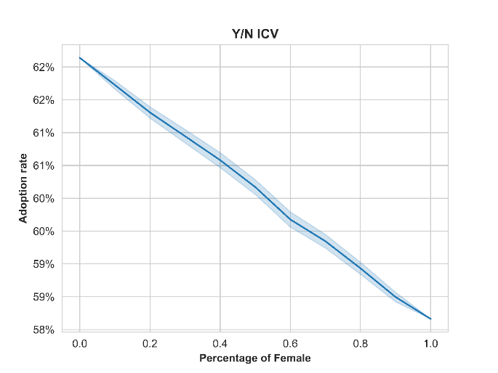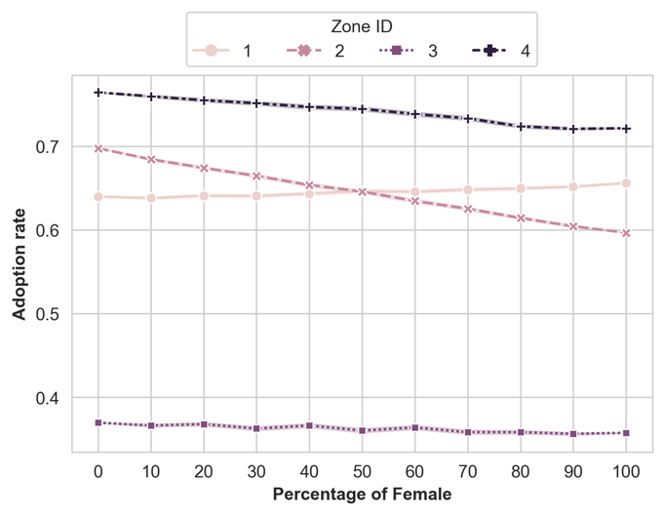

Figure 1. The self-reported ICV adoption Panel a depicts the Monte Carlo simulation of 500 iterations of each percentage for adoption rate in relation to wife respondent percentage. Panel b disaggregates the same data and same simulation by Zone IDs.
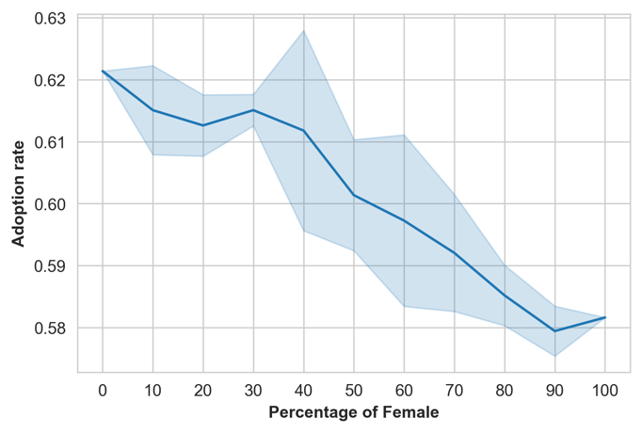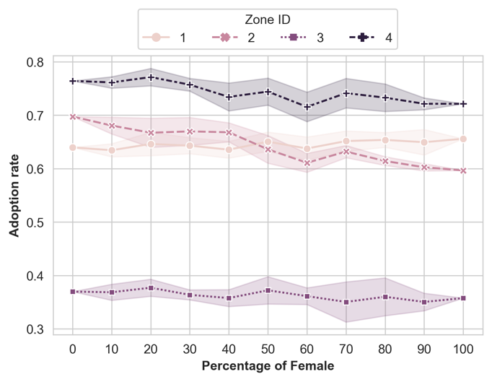
Figure 2. The self-reported ICV adoption. Panel a depicts the Monte Carlo simulation of 5 iterations of each percentage for adoption rate in relation to female respondent percentage. Panel b disaggregates the same data and same simulation by Zone IDs.

Systematic measurement error
Table 3 shows that the mean of the cassava adoption variable is higher for husbands than for wives in three of the four zones (Zone 2, 3, and 4). In other words, men are reporting that their household has adopted an improved cassava variety more than wives are. Overall, the table suggests that there are non-classical measurement errors in cassava variety adoption reporting. We compare the responses of husbands and wives to DNA fingerprinting data as an non-self reported measure of ICV presence on farm, and find that with wives less likely to report ICVs. There are no significant differences when looking at regional differences between husbands, wives, and DNA fingerprinting in zones 2 and 4. The significantly different responses between husbands and wives on access to productive assets, financial and knowledge assets, plot management, and plot sizes reflect well documented intrahousehold gender disparities in agricultural livelihoods in Nigeria.

Table 3. Descriptive statistics and results from the test and mean differences by gender
 | DNA | Husbands | Wives | Test statistics
Variable description. | [1] | [2] | [3] | [1]-[2] | [1]-[3] | [2]-[3]
Dependent variables.
Y/N ICV.
All observations. | 0.645 | 0.621 | 0.582 | 0.977 | 2.598*** | 2.224**
Zone 1. | 0.597 | 0.64 | 0.656 | -0.905 | -1.209 | -0.419
Zone 2. | 0.693 | 0.697 | 0.597 | -0.094 | 2.142** | 2.755***
Zone 3. | 0.503 | 0.37 | 0.358 | 2.639*** | 2.810*** | 0.47
Zone 4. | 0.793 | 0.764 | 0.721 | 0.631 | 1.59 | 1.227
All observations. | 1.775 | 1.512 | 1.39 | 4.355*** | 4.921*** | 1.828*
Zone 1. | 1.586 | 1.204 | 1.333 | 4.342*** | 1.961* | -1.164
Zone 2. | 1.66 | 1.773 | 1.555 | -1.375 | 0.722 | 1.690*
Zone 3. | 1.909 | 1.267 | 1.055 | 3.481*** | 4.400*** | 1.29
Zone 4. | 2.064 | 1.764 | 1.579 | 2.379** | 3.334*** | 1.622
Independent variablesn
Managed plots
Male Managed. |  | 0.978 | 0.621 |  |  | 6.026***
Female Managed. |  | 0.095 | 0.276 |  |  | -5.875***
Joint Managed. |  | 1.414 | 1.656 |  |  | -3.276***
Household Plots. |  | 2.506 | 2.565 |  |  | -1.181
Cassava Plot Size (K). |  | 12.683 | 7.68 |  |  | 6.487***
Income from Cassava (\%). |  | 3.133 | 3.173 |  |  | -0.873
Membership of a coop
Household. |  | 0.262 | 0.296 |  |  | -1.699*
Men Only. |  | 0.067 | 0.091 |  |  | -1.847*
Women Only. |  | 0.016 | 0.029 |  |  | -1.734*
Joint Coop. |  | 0.176 | 0.178 |  |  | -0.147
Credit Access
Household. |  | 0.451 | 0.379 |  |  | 3.193***
Male Only. |  | 0.112 | 0.043 |  |  | 5.163***
Female Only. |  | 0.018 | 0.033 |  |  | -1.862*
Joint Credit. |  | 0.321 | 0.303 |  |  | 0.804
Processing Access
Male Processing Access. |  | 0.232 | 0.254 |  |  | -0.665
Female Processing Access. |  | 0.743 | 1.126 |  |  | -6.269***
Joint Processing Access. |  | 1.753 | 1.136 |  |  | 8.775***
Household Asset Value (M)
Male Owned. |  | 108.519 | 5.323 |  |  | 3.939***
Female Owned. |  | 4.529 | 1.803 |  |  | 1.057
Total Household. |  | 113.06 | 5.504 |  |  | 3.965***
Production Asset Value (K)
Male Value. |  | 1484.778 | 359.289 |  |  | 0.808
Female Value. |  | 6.732 | 8.178 |  |  | -0.618
Total Value. |  | 1493.651 | 260.541 |  |  | 0.888
Household attributes
Age. |  | 50.543 | 40.435 |  |  | 28.879***
Education. |  | 9.342 | 8.029 |  |  | 6.858***
Main occupation. |  | 1.148 | 2.045 |  |  | -7.259***
Contribution to farm work (\%). |  | 80.206 | 70.089 |  |  | 8.646***
Men In House |  | 2.314 | 2.1 |  |  | 4.918***
Women In House |  | 2.23 | 2.169 |  |  | 1.491
Kids |  | 2.763 | 2.599 |  |  | 2.135**
Notes: Robust standard errors in parentheses ***p < 0.01, **p < 0.05, *p < 0.1.
Figure 3 shows the kernel density plot of the household ICV adoption reported by husbands and wives and the results of corresponding DNA fingerprinting results. Table 4 summarizes the paired t-test for self-reported and DNA fingerprinting results, to assess the alignment between wives’ self-reported household ICV adoption and the corresponding DNA fingerprinting test results, with a summary of these results in the table's first row. Similarly, the middle row of the table offers a summary of the test statistics for husbands, where we compared their self-reported household ICV adoption with the household's DNA fingerprinting data. The last row pertains to a distinct dataset, specifically households where wives self-identified as the household heads. This row investigates the consistency between their self-reported ICV adoption and the household's DNA test results.
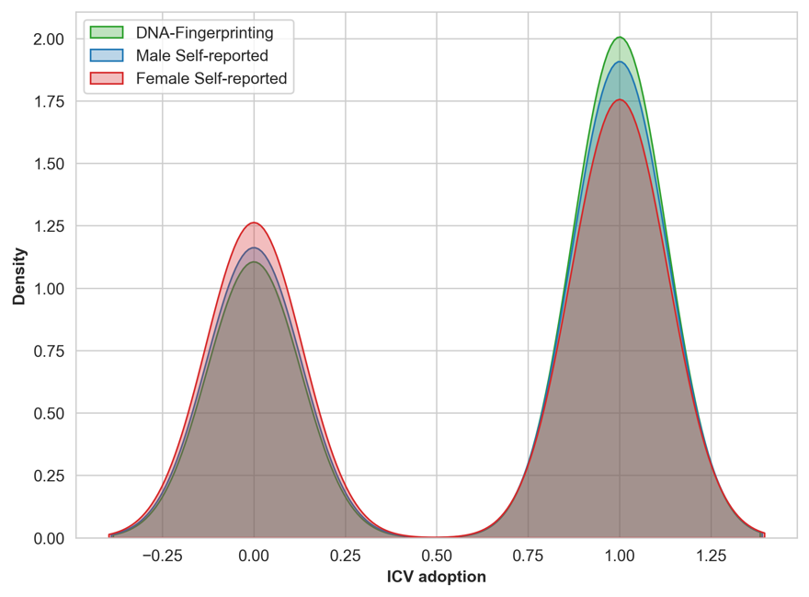

Figure 3. The comparison of the self-reported and DNA fingerprinting data

Table 4. Paired t-test results for self-reported and DNA fingerprinting data
Variable | T-Statistic | P-Value
Female respondents self-reported | -2.508 | 0.012
Male respondent self-reported | -0.870 | 0.384
Female respondent self-reported (Household head) | -0.433 | 0.673
Note: The paired t-test was conducted to compare the self-reported household ICV adoption among women with the corresponding DNA fingerprinting test results. The test results were summarized in the first row. Likewise, the middle row of the table presents a summary of the test statistics for men, where self-reported household ICV adoption was compared to the household's DNA test results. The final row pertains to a distinct dataset, comprising households in which wives identified themselves as the household heads, and it examines the concordance between their self-reported ICV adoption and the household's DNA test results.

For the self-reported adoption of ICV by wives, the probability of a negative response (no adoption) is higher compared to the results obtained from DNA testing (Figure 3). The paired t-test also rejected the null hypothesis that there is no difference in the two groups (wife self-reported vs DNA testing). Conversely, for husbands self-reported adoption of ICVs, the paired t-test does not reject the null hypothesis, suggesting no significant difference when compared to the DNA testing results. Both Figure 3 and Table 4 highlight the occurrence of false negatives in wives respondent self-reported data.
To explicitly demonstrate the biased regression results, we separated the intra-household dataset into the wife and husband datasets to test the structural differences between the two datasets. Table 5 summarizes the regression results derived from the probit model, which compares self-reported adoption and DNA testing for both husbands and wives. The regression results show that there is a positive relationship between coop members and household ICV adoption reported by husbands; however, no statistically significant relationship was found using wives’ self-reported dataset. It is observed that the estimates obtained from the wives’ self-reported data consistently exhibit smaller magnitudes in comparison to those derived from the male cohort.As outlined in eq. (7), there is a potential for attenuation in the estimates due to the presence of false negatives.

Table 5. Regression results (Probit model)
 | Husbands |  | Wives
 | Self-reported | DNA | Self-reported | DNA
Joint Coop | 0.130** | -0.009 | 0.076 | -0.062
 | (0.063) | (0.179) | (0.112) | (0.059)
Household Credit | -0.040 | -0.025 | -0.008 | 0.103
 | (0.065) | (0.122) | (0.102) | (0.142)
Extension Access | 0.432*** | 0.232** | 0.079 | -0.111
 | (0.064) | (0.096) | (0.113) | (0.137)
Consumption (%) | -0.002 | -0.001 | -0.004*** | 0.003
 | (0.004) | (0.007) | (0.001) | (0.002)
Zone 1 | -0.116*** | 0.194*** | -0.238*** | -0.156***
 | (0.027) | (0.032) | (0.046) | (0.049)
Zone 3 | -0.655*** | -0.600*** | -0.474*** | -0.574***
 | (0.026) | (0.100) | (0.025) | (0.042)
Zone 4 | 0.317*** | 0.335*** | 0.346*** | 0.329***
 | (0.069) | (0.110) | (0.057) | (0.051)
Age | 0.003 | 0.003 | 0.008*** | 0.015***
 | (0.005) | (0.008) | (0.003) | (0.003)
Education | -0.009 | 0.006 | 0.002 | 0.012
 | (0.006) | (0.020) | (0.023) | (0.017)
Household size | 0.071*** | 0.049** | -0.003 | -0.014
 | (0.014) | (0.022) | (0.013) | (0.033)
Main occupation: Salaried employment | -0.137 | -0.087 | 0.302** | -0.009
 | (0.246) | (0.302) | (0.141) | (0.314)
const | -0.046 | -0.169 | 0.146 | -0.232
 | (0.155) | (0.390) | (0.355) | (0.185)
N | 729 | 729 | 729 | 729
Notes:
1. The dependent variables are the self-reported ICV adoption and DNA test. The Self-report column summarizes the results based on the male and female self-reported data, respectively. On the other hand, the DNA test summarizes the results of when the DNA test is assumed as the dependent variable for the male and female self-reported data.
2. (*, **, ***) indicate statistical significance at the 10%, 5%, and 1% level.
3. Standard errors are clustered by region and reported in the parentheses.

It is noteworthy that, despite the statistical differences between the wives’ self-reported data and the DNA testing results (referenced in Table 3), the regression results positioned a consistency between the self-reported data from women who identified themselves as household heads and the DNA testing results. And for what was different? And for husbands…
Notably, both husbands and wives who identified as household heads reported ICV adoption in concordance with the DNA testing. Since only 2% of wives (n=13) identified as household heads, compared to over 99% of husbands), it is difficult to draw robust conclusions, but the results point at the position of household head in households where cassava cultivation is the main activity are more likely to identify improved varieties that align with corresponding DNA analysis.

Gender disparities in technology adoption
The dependent variable in the decomposition analysis is the ICV adoption in the plots that are managed by husbands and wives separately. The DNA fingerprinting test results are not applied in this gender decomposition analysis as the DNA tests assessed household-level adoption, which does not distinguish between male and female managed plots. To address the issue of measurement error and to analyze gender differences, our focus shifts to plot-level data in this following empirical analysis of gender inequality in technology adoption (see Figure 4). This approach allows for a distinct comparison of plots managed by husbands and wives.

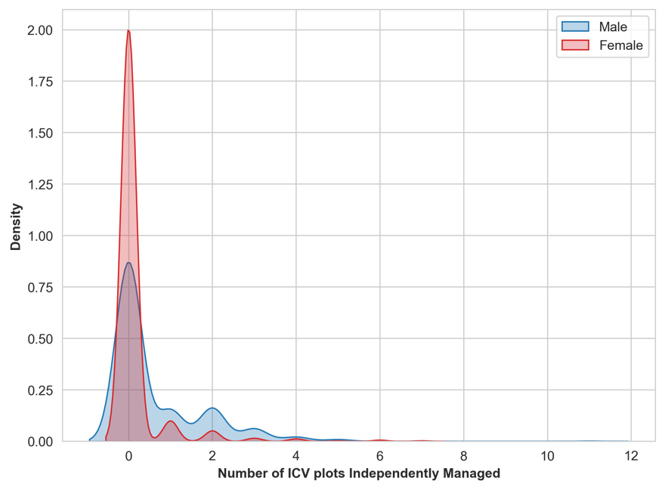

Figure 4. The comparison of the self-reported ICV adoption managed by husbands and wives.
Table 6 presents the Blinder-Oaxaca decomposition results of the spousal gap in ICV adoption. The adoption rate of ICV in separately managed plots is 0.17 and 0.65 for the wife and husband plot manager groups, respectively, indicating a notable difference of 0.48 between the two groups. The adoption rate for this analysis is lower than the household adoption rate because the decomposition analysis only focuses on plots managed by either husbands or wives to identify the gender gap in technology adoption. In addition to these separately managed plots, it is important to acknowledge that households also have plots jointly managed by both spouses.
The decomposition results suggest that the spousal adoption gap was primarily attributed to the differences in coefficients, as the overall coefficient effect is 0.43, the endowment effect is 0.02, and the interaction effect is 0.04 (detailed in Table 5). Notably, the breakdown of endowment effects illustrates that wives have less access to extension services compared to male farmers (Table 6). Both cooperative memberships and extension services demonstrate a diminished impact on wives’ ICV adoption compared to husbands.

Table 6. The Blinder-Oaxaca decomposition results in gender inequality
 | Wife plot manager | Husband plot manager | Gap
Mean by gender | 0.167 | 0.647 | -0.480
 | Endowments | Coefficients | Interaction
Aggregate decomposition | -0.019 | -0.426 *** | -0.035
 | (0.046) | (0.058) | (0.055)
Share of the gap | 3.96\% | 88.75\% | 7.29\%
Detailed decomposition
constant | 0.000 | -0.547 ** | -0.000
 | (0.000) | (0.252) | (0.000)
Joint Coop | 0.000 | -0.029 | -0.000
 | (0.004) | (0.025) | (0.004)
Household Credit | 0.005 | 0.018 | -0.003
 | (30.007) | (0.046) | (0.008)
Extension Access | -0.032 ** | -0.094 ** | 0.033 *
 | (0.016) | (0.047) | (0.018)
Consumption (%) | 0.004 | 0.136 | -0.004
 | (0.004) | (0.091) | (0.005)
Zone 1 | -0.000 | 0.001 | 0.000
 | (0.002) | (0.020) | (0.002)
Zone 3 | -0.000 | 0.017 | 0.000
 | (0.003) | (0.024) | (0.003)
Zone 4 | -0.000 | 0.040 ** | 0.000
 | (0.004) | (0.016) | (0.004)
Age | 0.027 | 0.386 | -0.077
 | (0.036) | (0.239) | (0.048)
Education | -0.009 | -0.015 | 0.002
 | (0.014) | (0.107) | (0.016)
Household size | -0.014 * | -0.245 ** | 0.015
 | (0.008) | (0.103) | (0.009)
Salaried employment | 0.000 | -0.002 | -0.001
 | (0.004) | (0.012) | (0.005)
(Base) | 0.000 | -0.094 *** | 0.000
 | (0.010) | (0.029) | (0.008)
Notes:
1. The dependent variables are the self-reported ICV plots each gender manages.
2. (*, **, ***) indicate statistical significance at the 10%, 5%, and 1% level.
3. Bootstrap standard errors.

Conclusion
This study has made contributions in understanding intrahousehold disparities in agricultural technology adoption, systematic measurement error and drivers of gender inequalities in improved varietal adoption. Through the development of a theoretical model and empirical analysis, we have illuminated the nuances of non-classical measurement errors related to gender in agricultural practices, which have potentially profound implications for agricultural technology adoption research.
First, we demonstrate a systematic false negative rate associated with in relation to technology adoption. The linear relationship between the rate of wife respondents included in the simulated dataset, and the reduction in adoption rate implies that respondent selection and study design influence the adoption rates. This could explain the large variation in ICV adoption rates we feature in Table 1. Our results strongly support the call for data best practices around intentionally including more women as respondents regardless of their household headship status (Doss, 2021). These results draw attention to the need for more consistent and robust study design approaches to better understand adoption patterns around improved crop varieties.
Second, we uncover differential endowment and systematic drivers of improved variety adoption decisions. There is a wealth of literature looking at the endowment and systematic drivers of agricultural productivity. For example, XXX JING AND JEISSON, CAN YOU INSERT A PARAGRAPH ON THE RELEVANCE TO ENDOWMENT VS SYSTEMATIC DRIVERS OF GENDER INEQUALITY. A LOT ON THIS IN THE GENDER PRODUCTIVITY GAP LITERATURE. Our decomposition analysis contributes to this space by identifying that systematic differences in access to agricultural education, extension and financial resources contribute to a lower rate of improved crop adoption between spouses. Systematic bias and inequality in extension systems and financial resources are well document. Further, access to education and extension are important determinants to improved variety adoption (Ruzzante et al., 2021; Acevedo et al., 2020). What we demonstrate is how these systems have a direct effect on improved crop adoption, and differential from individual endowment differences. Designing interventions to better meet the needs of women farmers should not only focus on their individual capabilities and endowments, but rather on these systematic affects.
Third, our results unveil that the zone in which respondents are located mirrors the literature on cassava adoption and agricultural productivity. The administrative zones in which respondents reside has been shown to be a significant driver of cassava trait preferences as well as adoption decisions. Oseni et al. (2015) show differential structural and endowment affects driving gender productivity gaps in Nigeria. Teeken et al. (2018 and 2021) demonstrate location as the primary driver of cassava trait preference differences in Nigeria, explaining more variation than gender of the respondent, poverty and food security level of the household. Furthermore, Takeshima (2018) demonstrated that proximity to plant breeding institutes in Nigeria positively impacted agricultural productivity and technical efficiency of farm households. Women’s roles in cassava production, processing and marketing vary regionally in Nigeria, with women playing a prominent role in the South East and South South as men engage more in off-farm activities (Korieh, 2010; Osuji et al., 2017). Given this cumulative evidence, we support the call of Oseni et al. (2015) to better tailor that agricultural development policy around regions, as well as Tavenner et al. (2022) to bring more intersectional analyses to agricultural research programs.
Most importantly our results bolster much needed attention to intentional research design, and respondent selection with regards to the unit of analysis. Doss (2021) draws attention to the perils of only focusing on individual and how this loses sight on the complex web of relationships that drive individual behavior. She further accentuates the need to move away from the narrow view of the household through focus on only spousal datasets for intrahousehold studies, which miss out on intergenerational relationships and dynamics that are equally important (Doss, 2021). Plot level analysis is increasingly normative in large survey panels, for example LSMS-ISA, but plot level data can be problematic if not examined through the lens of land rights and gender norms around plot management and farming more broadly (Doss, 2018). Using headship as a gender indicator is not necessarily indicative as to who actually makes decisions for agricultural production, with women in male-headed households make production decisions often jointly with their spouses (Peterman et al., 2010; Deere et al., 2009). This is also true for cassava producing households, where women household heads had differential cassava trait preferences than women who were spouses of male household heads (Chiwona-Karltun et al. 1998; Teeken et al.,. 2021). Our results make an important, and slightly contradictory contribution to this literature. We show that responses from women who are household heads are more in line with the results of the DNA fingerprinting data. The knowledge and decision-making endowments of a woman how is a household head may explain this greater apparent accuracy. This result supports the need for more nuanced data collection in agricultural technology adoption studies to balance data collection the multitudes of women’s roles as household heads, spouses and plot managers.
In conclusion, our study reinforces the necessity of gender-responsive agricultural policies and services based on representative and informed data. Precision research depends on inclusive representation and empowered participation to ensure agricultural development is effective and efficient for everyone. This not only promotes gender equality but also has the potential to significantly boost agricultural productivity and development.

Funding Acknowledgement:
The authors declare financial support was received for the research, authorship, and/or publication of this article. We acknowledge the support and funding of the CGIAR Excellence in Breeding (EiB) Platform.

References

However, if the condition in eq. (6) does not hold, the estimates (eq. (7)) are misleading (Meyer and Mittag, 2017).

